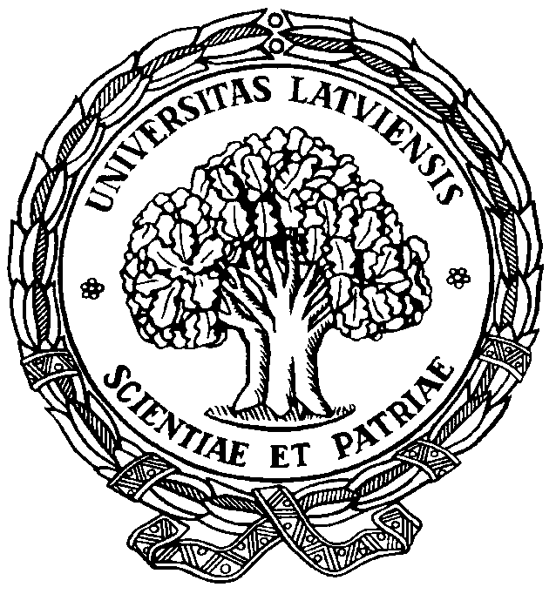

UNIVERSITY OF LATVIA

Faculty of Humanities
Department of Baltic Linguistics

55th

Conference of the
Arturs Ozols Day

Rīga
March 18, 2019

You are kindly invited to participate in the 55th Conference of the
Arturs Ozols Day

STANDARDIZATION AND CODIFICATION OF BALTIC LANGUAGES

The conference is devoted to the history of codification of the Standard Latvian and Standard Lithuanian.
2019 is the 140th anniversary of the first modern Latvian grammar in Latvian: „Latviešu valodas mācība. Sistemātisks kurss“ written in two parts: „Etimoloģija“ (1879) and „Sintaksa un ortogrāfija“ (1880 published by Stērstu Andrejs.

The conference will take place
on 18th of March, 2019

Working languages: Latvian,
Lithuanian,
English, German.
Please submit your application
and an abstract (ca 250–300 words)
before March 1, 2019

Registration fee: 10 EUR

Please, contact us may you wish to publish your paper in the internationally reviewed periodical Baltu filoloģija

Our address:

Department of Baltic Linguistics,
Faculty of Humanities,
University of Latvia,
Visvalža iela 4a,
Rīga LV–1050
Latvia

e-mail:
pvanags@latnet.lv
etrumpa@latnet.lv

phone: (+371) 67034905
Application form

First name, last name: _____________
________________________________

Title of paper: ___________________
________________________________________________________________________________________________________________________________

Address, phone, e-mail: ____________
________________________________________________________________________________________________________________________________________________________________________________________________

Affiliation, Position, Title/Degree: ___ ________________________________
________________________________________________________________
.

